Roald Medendorp

Module 1.2

5/27/2024

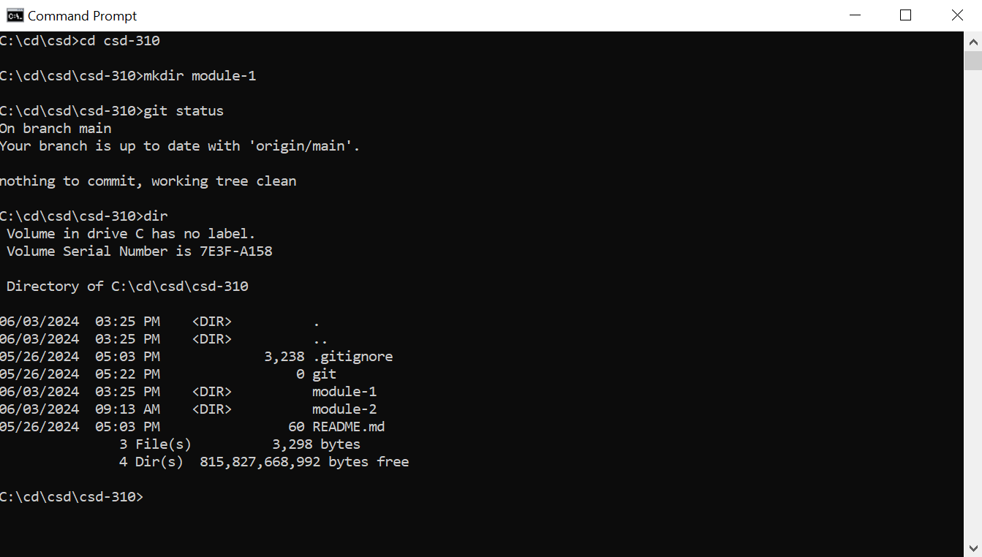

My link to my repository

https://github.com/Roald-Niels?tab=repositories